Delta Module 1 – Pre-interview Task
First name | Click or tap here to enter text. | Surname | Click or tap here to enter text.

Reasons for applying
Please outline briefly why you are interested in the Delta Module 1 course and how it might benefit you. Try to be specific.
Click or tap here to enter text.

Strengths and weaknesses
Consider what your strengths and weaknesses in relation to the course are. You may consider your experience, previous education/training, language awareness, reading done, teaching techniques, classroom management skills, teacher qualities, personal qualities etc.
Click or tap here to enter text.

Beliefs
Please outline 2 or 3 general principles which underlie your planning and teaching. Include examples of how you apply them in the classroom. Try to refer to a range of levels.
Click or tap here to enter text.

Knowledge about language
Please answer the following questions. Try not to refer to any sources, i.e. rely simply on your knowledge. It’s important that we can assess your knowledge accurately to ensure if you’re accepted, you can cope with the course.
1. Provide the term for each definition.
a the use of grammatical and lexical means to achieve connected text, either spoken or written. These include: reference words e.g. this, the, it; linkers e.g. However, and topic-related lexis
Click or tap here to enter text.
b a grammatical category which is used to indicate the time at which an action happens by changing the form of the finite verb. English has two: past and present e.g. he walked and he walks
Click or tap here to enter text.
c a test employing tasks which replicate real-life activities e.g. role-playing a job interview, writing a letter of complaint, or reading and completing an application form
Click or tap here to enter text.
d two words which differ from each other in pronunciation by only one phoneme e.g. met, mat; pin, bin
Click or tap here to enter text.
e a term for an ‘umbrella’ item of lexis which subsumes a range of more specific items
e.g. fruit in relation to apple, orange, pear
Click or tap here to enter text.
f an approach to developing learners’ writing skills that is informed by the belief that creating a written text is purely a matter of imitating elements that are provided in a model
Click or tap here to enter text.
2. Provide a definition and an appropriate brief example or illustration of each of the terms below.
a determiner
Click or tap here to enter text.
b modal auxiliary verb
Click or tap here to enter text.
c suggestopedia
Click or tap here to enter text.
d fresh starts
Click or tap here to enter text.

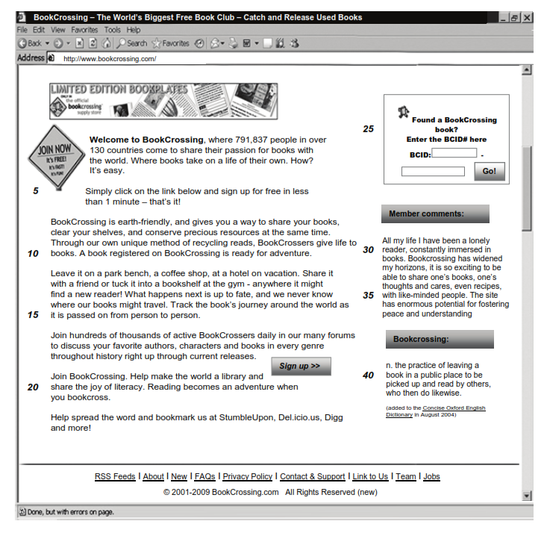
3. Please answer the questions below the text

a Comment on the form and meaning/use of the words in bold as they are used in the text.
i. our unique method of recycling reads (line 9)
Click or tap here to enter text.
ii. Reading becomes an adventure (line 20)
Click or tap here to enter text.
iii. Found a BookCrossing book? (lines 24-25)
Click or tap here to enter text.
vi. with like-minded people (line 35)
Click or tap here to enter text.

b Comment on the use of relative clauses and relative pronouns in the following extracts in the following extracts from the text.
i. Bookcrossing, where 791,837 people in over 130 countries come to share their passion for books (lines 1-2)
Click or tap here to enter text.
ii. A book registered on BookCrossing is ready for adventure. (line 10)
Click or tap here to enter text.

c Comment on the features of connected speech likely to occur in the following:
• Used books
• as it is passed on
Click or tap here to enter text.

4. Methodology
What are the advantages and disadvantages of teaching learners phonemic script (IPA)? Please outline at least 3 or 4 reasons for and against.
Click or tap here to enter text.

